Guide to Good Decision Making Exercise¹

A cycle can be used to show the steps in making a career choice. Use the blank spaces below to note your thoughts and feelings about your career choice.

Communication
Knowing I Need to Make a Choice

Events - things that happen to me
Example: "I need to choose a major by next
semester."

Comments from my friends and relatives
Example: "My roommate said that I'll have
problems if I don't make a decision soon."

The way I feel
"I'm scared about committing myself."

Avoiding my problems
"I'll get started next week."

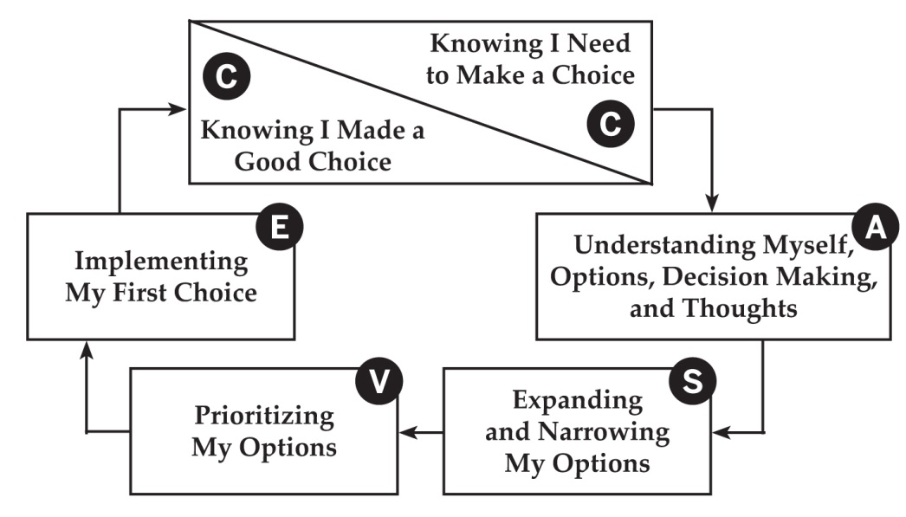

Physical problems
"I'm so upset about this, I can't eat."

The CASVE Cycle

¹ Adapted from Sampson, J. P., Jr., Peterson, G. W., Lenz, J. G., & Reardon, R. C. (1992). A cognitive approach to career services: Translating concepts into practice. The Career Development Quarterly, 41, 67-74.

Analysis
Understanding Myself, Options, Decision Making, and Thoughts

Understanding myself, such as
My values
Example: security

My interests
Example: working with people

My skills
Example: using a computer to plan a budget

My employment preferences
Example: limited travel

Understanding my options
Understanding specific occupations, programs
of study, or jobs

Occupation, program of study, or job:

_______________________________________
What I know about the occupation, program
of study, or job:

Occupation, program of study, or job:

_______________________________________
What I know about the occupation, program
of study, or job:

Occupation, program of study, or job:

_______________________________________
What I know about the occupation, program
of study, or job:

Occupation, program of study, or job:

_______________________________________
What I know about the occupation, program
of study, or job:

Occupation, program of study, or job:

_______________________________________
What I know about the occupation, program
of study, or job:

Occupation, program of study, or job:

_______________________________________
What I know about the occupation, program
of study, or job:

Occupation, program of study, or job:

_______________________________________
What I know about the occupation, program
of study, or job:

Occupation, program of study, or job:

_______________________________________
What I know about the occupation, program
of study, or job:

Understanding how occupations, programs
of study, or jobs are organized
Example:
Realistic Occupations
Investigative Occupations
Artistic Occupations
Social Occupations
Enterprising Occupations
Conventional Occupations

Understanding how I make important decisions
Example: Thinking, feeling, and/or getting advice from others

Understanding thoughts related to my decisions
Self-talk
Example: "I'll never be able to make a good
career choice."

Self-awareness
Example: "I'm getting very scared about this."

Monitoring and controlling my self-talk
Example: "I can't really predict the future and imagining failure is not going to help me find a good job."

Synthesis
Expanding and Narrowing My Options

Identify occupations, programs of study, or
jobs that fit my values, interests, and skills

Pick the 3 to 5 best occupations, programs of study, or jobs using what I learned from
"Understanding Myself and My Options"

Valuing
Prioritizing My Options

Occupation, program of study, or job | Benefits to myself? My family? Friends? Cultural group? Community? Society? | Costs to myself? My family? Friends? Cultural group? Community? Society?

Prioritize my occupations, programs of study, or jobs

1st _______________________________________

2nd ______________________________________

3rd _______________________________________

1) ________________________________________

2) ________________________________________

3) ________________________________________

4) ________________________________________

5) ________________________________________

4th _______________________________________

5th _______________________________________

My first choice:

________________________________________________

My back-up choice(s):

________________________________________________
________________________________________________

Execution
Implementing My First Choice

(Complete the sections below that apply to you)

Plan - My plan for getting education or training

1)

2)

3)

4)

Try Out - Get experience (full time, part-time, volunteer) and take courses or get training to test my choice

Apply - Steps to apply for and get a job or pursue further education

1)

2)

3)

4)

5)

Communication
Knowing I Made a Good Choice

Have events changed?

How did my family and friends react to my choice?

How do I feel now?

Am I avoiding doing what needs to be done?

Am I satisfied with my choice?

Am I confident with my choice?

career.fsu.edu | 850-644-6431

